**Praktik Pembuatan Akun Wokwi dan Github**

*Amanda Dewi Ramadhani*

Fakultas Vokasi , Universitas Brawijaya

Email: Amanda_dewi_r@student.ub.ac.id

**Abstract**

Traffic light systems are essential for regulating vehicle flow at intersections. This project aims to simulate a traffic light system using Wokwi and VS Code, integrating an Arduino microcontroller to control red, yellow, and green LEDs. Wokwi serves as a virtual simulation platform, allowing code testing without physical hardware, while VS Code acts as the primary development environment. By implementing Arduino programming, the timing of each LED is managed to mimic real-world traffic signals. This simulation provides a fundamental understanding of traffic light operations and microcontroller-based automation in traffic management.

*Keywords—Wokwi, GitHub, IoT, version control, collaboration*

**1. Introduction**

**1.1 Background**

A traffic light is a signaling system used to regulate vehicle flow at intersections. In the practice of creating a traffic light using Wokwi and VS Code, we will simulate an electronic circuit consisting of red, yellow, and green LEDs controlled by a microcontroller, such as an Arduino. Wokwi serves as a simulation platform to test the code without physical hardware, while VS Code functions as a code editor for writing and uploading programs to the microcontroller. By utilizing Arduino programming (via VS Code), we can control the timing of each light turning on and off according to traffic rules, making this practice useful for understanding how traffic lights work in the real world.

**1.2 Objectives**

This experiment aims to introduce students to the process of creating accounts, setting up projects, and managing code using Wokwi and GitHub as a foundational step towards developing more complex IoT systems. Tujuan dari proyek ini adalah untuk mensimulasikan sistem traffic light menggunakan Wokwi dan VS Code guna memahami cara kerja serta logika pengendalian lampu lalu lintas dengan mikrokontroler Arduino. Melalui simulasi ini, pengguna dapat mempelajari pemrograman Arduino untuk mengatur waktu nyala dan mati lampu sesuai aturan lalu lintas, sekaligus mengembangkan keterampilan dalam menggunakan VS Code sebagai lingkungan pengembangan. Selain itu, proyek ini bertujuan untuk meningkatkan pemahaman tentang aplikasi sistem otomatisasi berbasis mikrokontroler dalam manajemen lalu lintas.

**2. Methodology**

**2.1 Tools & Materials**

* **Microcontroller**: Virtual Arduino Uno (via Wokwi)
* **Software**: Wokwi (https://wokwi.com), GitHub (https://github.com), Vs Code, PlatformIO IDE,
* **Internet Access**

**2.2 Implementation Steps**

1. Open the Wokwi and Vscode.
2. Create new project in PlatformIO IDE. And open wokwi an then Choose ESP 32 to create traffic light
3. Then compile the c++ code in main.cpp.
4. After the compiling process is successful. there are 2 important files that will be used in the simulation process. namely the firmware.bin and firmware.elf files.
5. Copy the relative path of each file into the wokwi.toml file.
6. Then create a diagram.json file and copy and paste from the json diagram on the wokwi.com platform.
7. Before starting the simulation, request a new license by running the > Wokwi command: Request a New License.
8. The last step is to run the simulation by typing the command

> Wokwi: Start Simulator

**3. Results and Discussion**

**3.1 Experimental Results**

|  |  |  |
| --- | --- | --- |
| **Platform** | **Completed Task** | **Key Outcome** |
| Wokwi | Traffic light simulation | The traffic lights successfully change colors at specified intervals |
| VS Code | Writing and uploading Arduino code | The Arduino code was successfully written, compiled, and uploaded to the microcontroller |

Red light screenshot result:

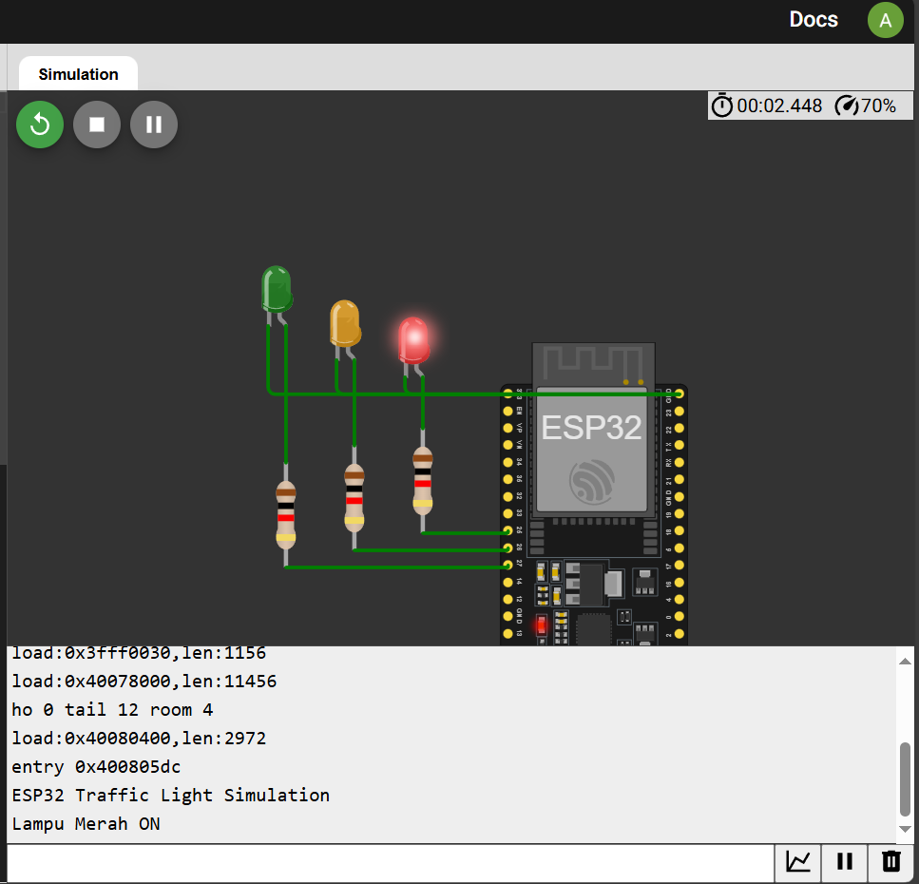

Yellow light screenshot result:

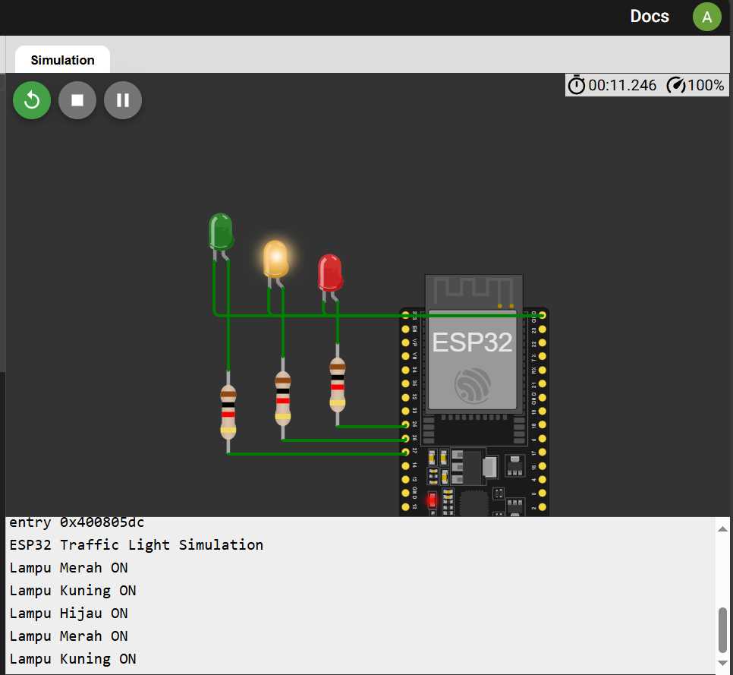

Green light screenshot result:

